**Hypnosis: Become a Non-Smoker for Life!**  
By Karen Branch, Certified Hypnotherapist

[Share on facebook Share on twitter Share on email Share on print More Sharing Services **71**](http://www.allthingshealing.com/readarticle.php?itemID=16&articleID=3741)

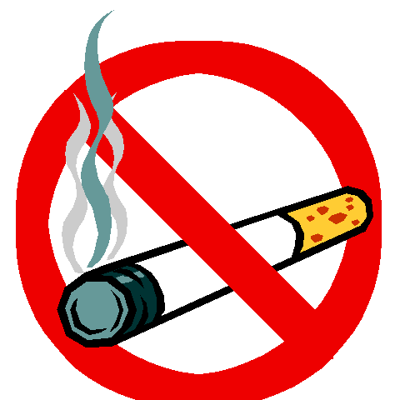So, you are ready to kick the habit - to become a non-smoker and regain control of your health and your life. Good for you!  
  
Nearly everyone knows that smoking is one of the single worst things you can do for your health. It delivers thousands of toxic chemicals into the body and causes a massive amount of lung and heart disease. It steals away health, time, money and self-esteem. But still, these facts are not enough to make most people quit.  
  
Your conscious mind knows you should quit; this is the part of your mind that knows of the dangers and consequences of smoking. But the conscious mind controls only about 12% of the mind; the other 88% is controlled by the subconscious mind. Your subconscious mind has no reasoning or analytical ability; it is emotional, instinctual and controlled by habit patterns. It runs on the pursuit of pleasure and the avoidance of pain.  
  
And somewhere along the way, your subconscious began to associate smoking with pleasure, relief from stress or boredom, relaxation, socializing and fun. For your subconscious mind, even the thought of quitting becomes uncomfortable and painful.  
  
So an interesting dynamic begins: You decide to quit smoking with your conscious mind, but your subconscious mind thinks this is a terrible idea. After all, you've programmed it to believe that smoking does all kinds of wonderful things for you. It feels threatened, feeling that something important to your life is being taken away.

Then the battle begins between the 12% and the 88% - and guess which one usually wins? Right - the subconscious clobbers the conscious mind and makes it very difficult to stop smoking.  
  
Enter hypnosis. While in a deeply relaxed state of body and mind, you are able to communicate directly with your subconscious mind. Your subconscious mind is very suggestible. It obeys your every command. After all, you programmed it to believe pumping your body full of toxins while smoking was a good idea. Your subconscious mind even began to believe the lie that cigarettes can relax you and make you feel good. That's how powerful your mind really is! In hypnosis, you begin the process of reprogramming and reversing the pain/pleasure association.   
  
When in the very deeply relaxed state, you are up to 100 times more open and receptive to ideas, images and suggestions. It is an excellent state of mind to program the benefits of being a non-smoker: better health, easier breathing, stronger heart and lungs, smelling fresher and cleaner, saving money, gaining control and self confidence and so much more. Soon, your subconscious mind and conscious mind are on the same page, and you are unstoppable. They both agree becoming a non-smoker is the best decision you ever made!

**Please "Add a Comment" at the bottom of this page or** [**blog in our Forum here**](http://www.allthingshealing.com/athforum/ath_forum.php?cat=150)**.   
*Please do not use apostrophes in your comments.***

[Share on facebook Share on twitter Share on email Share on print More Sharing Services **71**](http://www.allthingshealing.com/readarticle.php?itemID=16&articleID=3741)

**About the Author**

**Karen Branch** is a Certified Hypnotherapist in the Atlanta, GA area. She has been the owner of New Attitudes Hypnosis, a private hypnosis practice, since 1985 and has helped hundreds of people tap into the power of their subconscious mind to reach their goals. She can be reached at 770-232-9970; or visit her website at[www.NewAttitudeHypnosis.com](http://www.newattitudehypnosis.com)